**ABSTRACT**

Flood is enormous measure of water passing a flood on a land. Flood figure (FF) framework issue an admonition relating to water level or releases through pressure driven structures. Flood conjecture (FF) increment the ability and headway in hydrology to moderate the risks utilizing machine leanings with ANN. Flood determining utilizing AI calculation (MLA) strategy comprehend to learn and further develop framework scale to relieve flood risks as per the climatechange. This exploration is completing for flood guaging on Upper Wardha project across Wardha waterway bowl. Flood guaging (FF) utilizing constant assessment gives chances of flood esteem and by utilizing the estimated inflow, pace of inflow in supply can choose the hour of activity for example opening and shutting of door progressively with ANN

**CHAPTER-1**

**INTRODUCTION**

1. **INTRODUCTION**

Flood Determining can be characterized as a course of assessment of time and term in light of geographical qualities of any stream bowl which decreased the perils to human existence and climate too. Flood Estimating method challenge to foresee event and greatness with season of glimmer flood. Flood occurred because of proceed with precipitation with particular time. Conventional precipitation additionally adds to change with time into lethal flood. Flood estimating procedures assume a crucial and significant part to relieve the perils for non-primary designs with financially savvy the executives. Flood anticipating stations cover the organization of flood inclined region to give flood advance notice to organization. Determining inflow additionally utilized for the activity of pressure driven designs, for example, dam on which opening and shutting of entryways on spillways. Flood guaging methods and Flood cautioning framework are required different sort of designs of flood. Flood might be diminished by developing designs like dams, weirs, dykes yet can't take out the gamble. Flood determining methods ready to moderate the risks for populace and climate progressively with an early advance notice [1]. Flood anticipating has been approach through precipitation - overflow and flood directing model. Flood conjecture foresee inflow at chose area with HFL esteem at chosen areas of stream with time relies upon watershed or catchment region. Afterward, downstream side predicts the flood restricted with movement time with an evaluation of vulnerabilities to appropriately uphold the chiefs exercises [9]. Flood anticipating utilizing AI calculation (MLA) technique comprehend to learn and further develop framework scale to relieve flood perils as per the environmental change with the assistance of simulated intelligence. Flood determining utilized for making the AI calculation with past and genuine records of flood with ongoing information utilizing precipitation measures for various returning time. The dataset sources are precipitation spillover, water levels utilizing programmed downpour checks with satellites innovation, invasion rate and so on.

.

**CHAPTER-2**

**LITERATURE SURVEY**

**2.LITERATURE SURVEY**

**1.The financial advantage of early flood admonitions in Europe. Environ.**

**Creator: Pappenberger, F.; Cloke, H.L.; Parker, D.J.; Wetterhall, F.; Richardson, D.S.; Thielen, J**

**Conceptual:**

Successful catastrophe risk the board depends on science-based answers for close the hole among anticipation and readiness measures. The meeting on the Unified Countries post-2015 structure for catastrophe risk decrease features the requirement for cross-line early admonition frameworks to reinforce the readiness periods of calamity risk the board, to save lives and property and diminish the general effect of serious occasions. Mainland and worldwide scale flood estimating frameworks give fundamental early flood cautioning data to public and global common security specialists, who can utilize this data to go with choices on the most proficient method to plan for impending floods. Here the expected financial advantages of early flood alerts are assessed in view of the conjectures of the mainland scale European Flood Mindfulness Framework (EFAS) utilizing existing flood harm cost data and estimations of potential stayed away from flood harms. The advantages are of the request for 400 Euro for each 1 Euro contributed. A responsiveness examination is acted to test the vulnerability in the technique and foster an envelope of possible money related advantages of EFAS alerts. The outcomes give obvious proof that there is logical a significant financial advantage in this cross-line mainland scale flood early admonition framework. This supports the more extensive drive to carry out early advance notice frameworks at the mainland or worldwide scale to work on our versatility to normal perils.

Measurable examination of the effect of radar precipitation vulnerabilities on water assets modelin

Creator: He, X.; Refsgaard, J.C.; Sonnenborg, T.O.; Vejen, F.; Jensen, K.H

Conceptual:

Vulnerability examination in hydrological demonstrating has turned into a fundamental stage in the logical translation of model outcomes and a helpful device to help navigation. Among numerous vulnerability sources in the demonstrating practice, vulnerabilities in precipitation assessment assume a significant part since it is the super main thrust for other hydrological processes. The current review exhibits a factual strategy for creating radar precipitation acknowledge that record for the vulnerabilities in radar-based quantitative precipitation assessment (QPE). The irregular inspecting method used to produce stochastic vulnerability fields depends on successive Gaussian reproduction. The hydrological effect of the vulnerabilities in radar QPE is broke down by proliferating the precipitation troupe through a conveyed and coordinated water assets model. The review shows that the vulnerability of the recreated stream release relies upon the force of the precipitation input signal. The coefficient of variety is determined for reenacted stream release and groundwater re-energize at subcatchments with different sizes. The outcomes uncover solid scale reliance showing higher varieties of hydrological vulnerabilities at more modest catchments, particularly for catchment regions less than 50 km2. The vulnerabilities from precipitation input are for the most part enhanced in the hydrological model. This impact is more subtle for groundwater re-energize yet rather significant for stream release, where the coefficient of variety increments by an element of

**CHAPTER-3**

**SYSTEM ANALYSIS**

**SYSTEM ANALYSIS**

SYSTEM ANALYSIS

**EXISTING SYSTEM:**

The current review completed on Wardha Waterway bowl .The Upper Wardha project is one of the significant water system project in Vidharbha locale of Maharashtra state. This task is across Wardha Stream close to town Simbhora Taluka Morshi of Amravati area. The Upper Wardha project comprises of earthen dam on a the two flanks with a midway found gated spillway and waterway on left and right flanks. The Upper Wardha dam has absolute grass water system (GI) of 11690 (ha) with gross limit of 786 MCM in Godavari Stream Bowl with yearly precipitation in the catchment is 840 mm\

**DIS ADVANTAGES OF EXISTING SYSTEM:**

1) Less precision

2)low Effectiveness

**.**

**PROPOSED SYSTEM**

Flood determining procedure coordinated technique reasonably founded on accessible information and an evaluation of rating measures with a motivated presentation. Flood guaging involving continuous assessment gives chances of flood esteem in GUI. Flood assessment utilizing AI continuously can compute huge information quickly. Correlation between flood demonstrating by AI and stochastic technique (for example Muskinghum strategy) gives AI is precise, simple and can be applied for quantities of estimation.

**ADVANTAGES** **OF PROPOSED SYSTEM**

1) High precision

2)High productivity

**FEASIBILITY STUDY**

**SYSTEM STUDY FEASIBILITY STUDY**

The practicality of the task is examined in this stage and strategic agreement is advanced with an extremely broad arrangement for the undertaking and a few quotes. During framework examination the plausibility investigation of the proposed framework is to be done. This is to guarantee that the proposed framework isn't a weight to the organization. For plausibility investigation, some comprehension of the significant prerequisites for the framework is fundamental.

Three key contemplations engaged with the achievability investigation are

**• Conservative Possibility**

**• Specialized Plausibility**

**• SOCIAL Plausibility**

**Conservative Achievability**

**This study is completed to check the monetary effect that the framework will have on the association. How much asset that the organization can fill the innovative work of the framework is restricted. The uses should be legitimate. Accordingly the created framework also affordable and this was accomplished in light of the fact that the greater part of the advances utilized are openly accessible. Just the modified items must be bought.**

**Specialized FEASIBILI**

**This study is completed to check the specialized possibility, or at least, the specialized necessities of the framework. Any framework created should not have a popularity on the accessible specialized assets. This will prompt high requests on the accessible specialized assets. This will prompt high requests being put on the client. The created framework should have an unassuming prerequisite, as just insignificant or invalid changes are expected for executing this framework.**

**SOCIAL Attainability**

**The part of study is to actually take a look at the degree of acknowledgment of the framework by the client. This incorporates the method involved with preparing the client to productively utilize the framework. The client should not feel compromised by the framework, rather should acknowledge it as a need. The degree of acknowledgment by the clients exclusively relies upon the strategies that are utilized to teach the client about the systemand to make him acquainted with it. His degree of certainty should be raised with the goal that he is additionally ready to make some valuable analysis, which is invited, as he is the last client of the framework.**

**CHAPTER-4**

**SYSTEM REQUIREMENTS**

**4. SYSTEM REQUIREMENTS**

**Equipment and programming prerequisites:**

**HardWare requirments :**

• framework : i3 or above.

• slam : 4 gb.

• hard circle : 40 gb

**Programming requirments :**

• working framework : windows8 or above.

• coding language : python

• front end : html/css

• backend : my sql

• devices : pycharm

• server : django

**Functionalrequirements**

information assortment: assemble applicable information sources including climate information, waterway levels, territory data, and authentic flood information.

preprocessing: clean and preprocess the gathered information to guarantee consistency, exactness, and similarity for ai calculations.

include choice: distinguish and choose pertinent elements from the dataset that are characteristic of flood events and can add to exact estimating.

model turn of events: foster ai models, like relapse, grouping, or time series models, to anticipate flood events in light of the chose highlights.

preparing and approval: train the ai models utilizing authentic information and approve their presentation utilizing suitable assessment measurements and approval methods.

constant expectation: carry out systems to persistently screen approaching information and give ongoing flood estimates utilizing the prepared ai models.

cautioning framework: foster a making framework aware of inform pertinent specialists and inhabitants when the gamble of flooding surpasses predefined limits in view of the estimated probabilities.

**Non-practical prerequisites**:

non-practical prerequisite (nfr) indicates the quality trait of a product framework. they judge the product framework in view of responsiveness, ease of use, security, movability and other non-utilitarian principles that are basic to the progress of the product framework. illustration of nonfunctional prerequisite, "how quick does the site load?" neglecting to meet non-practical necessities can bring about frameworks that neglect to fulfill client needs. non-utilitarian necessities permits you to force limitations or limitations on the plan of the framework across the different spry overabundances. model, the site ought to stack in 3 seconds when the quantity of synchronous clients are> 10000. portrayal of non-utilitarian necessities is similarly essentially as basic as a functionalrequirement.

• usabilityrequirement

serviceabilityrequirement

.manageabilityrequirement

• recoverabilityrequirement

• securityrequirement

• information trustworthiness necessity

• capacityrequirement

• availabilityrequirement

• scalabilityrequirement

• interoperabilityrequirement

• reliabilityrequirement

• maintainabilityrequirement

• regulatoryrequirement

• environmentalrequirement

**Purpose**

This overview distinguishes the cutting edge of ML techniques for flood expectation where peer-surveyed articles in high level subject fields are checked on. Among the articles distinguished, through search questions utilizing the pursuit system, those including the exhibition assessment and correlation of ML strategies were given need to be remembered for the audit to recognize the ML techniques that perform better specifically applications. Besides, to pick an article, four kinds of value measure for each article were thought of, i.e., source standardized influence per paper (Clip), CiteScore, SCImago diary rank (SJR), and h-file. The papers were checked on as far as flood asset factors, ML strategies, expectation type, and the acquired outcomes. The applications in flood expectation can be characterized by flood asset factors, i.e., water level, stream flood, soil dampness, precipitation release, precipitation, waterway inflow, top stream, stream, precipitation overflow, streak flood, precipitation, streamflow, occasional stream, flood top release, metropolitan flood, plain flood, groundwater level, precipitation stage, flood recurrence examination, flood quantiles, flood level, outrageous stream, storm flood, hurricane precipitation, and day to day streams [59]. Among these key affecting flood asset factors, precipitation and the spatial assessment of the hydrologic cycle played the most momentous part in overflow and flood displaying

**CHAPTER-5**

**SYSTEM ARCHICTURE**

**SYSTEM ARCHICTURE:**

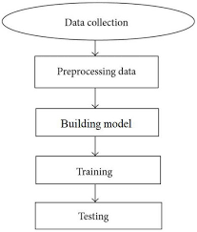

**RELATED WORK :**

The overall uses of ML in all flood asset factors according to the viewpoint of ML displaying and information driven forecast frameworks. Regardless, ML calculations have significant qualities that should be painstakingly thought about. The first is that they are comparable to their preparation, by which the framework learns the objective undertaking in view of past information. In the event that the information is scant or doesn't cover assortments of the assignment, their learning misses the mark, and consequently, they can't perform well when they are invested into effort. Hence, utilizing strong information improvement is fundamental through, e.g., executing a dissemination capability of amounts of loads [56], invariance evaluations to hold the gathering qualities [57], or recuperating the missing factors utilizing causally subordinate coefficients [58]. The subsequent perspective is the capacity of every ML calculation, which might shift across various kinds of undertakings. This can likewise be known as a "speculation issue", which shows how well the prepared framework can foresee cases it was not prepared for, i.e., whether it can foresee past the scope of the preparation dataset. For instance, a few calculations might perform well for momentary expectations, however not so much for long haul expectations. These attributes of the calculations should be explained as for the sort and measure of accessible preparation information, and the kind of expectation task, e.g., water level and streamflow. In this audit, we investigate instances of the utilization of different ML calculations for different sorts of undertakings. At the theoretical level, we chose to partition the objective errands into present moment and long haul forecast. We then, at that point, investigated ML applications for flood-related undertakings, where we organized ML strategies as single techniques and cross breed strategies. Cross breed strategies are those that join more than one ML strategy. Here, we ought to take note of that this paper overviews ML models utilized for expectations of floods on destinations where downpour checks or insightful detecting frameworks utilized. Our objective was to review forecast models with different lead times to floods at a specific site. According to this point of view, spatial flood expectation was not engaged with this review, as we didn't concentrate on forecast models used to appraise/distinguish the area of floods. As a matter of fact, we were concerned exclusively with the lead time for a distinguished site

**CHAPTER-6**

**MODULES**

**MODULES:**

transfer X-ray pictures dataset : utilize this button to get transfer pictures.

Create pictures train and test model : utilize this button to get produce pictures train and test model.

Create profound learning CNN model : utilize this button to get profound learning CNN model.

Get drive HQ pictures: utilizing this button to get open drive HQ

Foresee growth :utilize this button to get anticipate cancer.

**CHAPTER-7**

**SYSTEM DESIGN**

**1 .UMLDIAGRAMS :**

UML represents Brought together Demonstrating Language. UML is a normalized universally useful demonstrating language in the field of item situated programming. The standard is made due, and was made by, the Article The board Gathering.

The objective is for UML to turn into a typical language for making models of item situated PC programming. In its ongoing structure UML is contained two significant parts: a Meta-model and a documentation. Later on, some type of strategy or process may likewise be added to; or related with, UML.

The Brought together Demonstrating Language is a standard language for determining, Perception, Developing and recording the relics of programming framework, as well concerning business displaying and other non-programming frameworks.

The UML addresses an assortment of best designing practices that have demonstrated fruitful in the displaying of huge and complex frameworks.

The UML is a vital piece of creating objects situated programming and the product improvement process. The UML utilizes generally graphical documentations to communicate the plan of programming projects.

Objectives:

The Essential objectives in the plan of the UML are as per the following:

1. Provide clients a prepared to-utilize, expressive visual demonstrating Language with the goal that they can create and trade significant models.

2. Provide extendibility and specialization systems to expand the center ideas.

3. Be free of specific programming dialects and advancement process.

4. Provide a proper reason for figuring out the displaying language.

5. Encourage the development of OO instruments market.

6. Support more elevated level improvement ideas like coordinated efforts, systems, examples and parts.

7. Integrate prescribed procedures.

**USE CASE DIAGRAM:**

A utilization case graph in the Bound together Displaying Language (UML) is a sort of conduct chart characterized by and made from a Utilization case examination. Its motivation is to introduce a graphical outline of the usefulness given by a framework concerning entertainers, their objectives (addressed as use cases), and any conditions between those utilization cases. The principal motivation behind a utilization case chart is to show what framework capabilities are performed for which entertainer. Jobs of the entertainers in the framework can be portrayed.

# CLASS DIAGRAM:

In computer programming, a class graph in the Brought together Demonstrating Language (UML) is a kind of static design chart that portrays the construction of a framework by showing the framework's classes, their properties, tasks (or strategies), and the connections among the classes. It makes sense of which class contains data.



**SEQUENCE DIAGRAM:**

A succession graph in Brought together Demonstrating Language (UML) is a sort of collaboration chart that shows how cycles work with each other and in what request. It is a build of a Message Succession Graph. Grouping graphs are now and then called occasion charts, occasion situations, and timing outlines.

**COLLABRATION DIAGRAM:**

Action charts are graphical portrayals of work processes of stepwise exercises and activities with help for decision, emphasis and simultaneousness. In the Bound together Displaying Language, action graphs can be utilized to depict thebusiness and functional bit by bit work processes of parts in a framework. An action outline shows the general progression of control.



**CHAPTER-8**

**IMPLEMENTATION**

**8.IMPLEMENTATION**

**8.1. Software Environment**

**What is Python:**

The following are a few realities about Python.

Python is presently the most broadly utilized multi-reason, significant level programming language.

Python permits programming in Item Arranged and Procedural ideal models. Python programs for the most part are more modest than other programming dialects like Java.

Developers need to type generally less and space prerequisite of the language, makes them discernible constantly.

Python language is being utilized by practically all tech-goliath organizations like - Google, Amazon, Facebook, Instagram, Dropbox, Uber… and so on.

The greatest strength of Python is immense assortment of standard library which can be utilized for the accompanying -

• AI

• GUI Applications (like Kivy, Tkinter, PyQt and so forth )

• Web systems like Django (utilized by YouTube, Instagram, Dropbox)

• Picture handling (like Opencv, Cushion)

• Web scratching (like Scrapy, BeautifulSoup, Selenium)

• Test structures

• Sight and sound

**Advantages of Python :-**

# How about we perceive how Python rules over different dialects.

# 1. Broad Libraries

# Python downloads with a broad library and it contain code for different purposes like normal articulations, documentation-age, unit-testing, internet browsers, stringing, information bases, CGI, email, picture control, from there, the sky is the limit. Thus, we don't need to physically compose the total code for that.

# 2. Extensible

# As we have seen before, Python can be reached out to different dialects. You can keep in touch with a portion of your code in dialects like C++ or C. This proves to be useful, particularly in projects.

# 3. Embeddable

# Free to extensibility, Python is embeddable too. You can put your Python code in your source code of an alternate language, as C++. This allows us to add prearranging capacities to our code in the other language.

# 4. Further developed Efficiency

# The language's effortlessness and broad libraries render developers more useful than dialects like Java and C++ do. Additionally, the way that you want to compose less and accomplish more things.

# 5. IOT Open doors

# Since Python shapes the premise of new stages like Raspberry Pi, it sees as the future splendid for the Web Of Things. This is a method for interfacing the language with this present reality.

# While working with Java, you might need to make a class to print 'Hi World'. In any case, in Python, simply a print explanation will do. It is likewise very simple to learn, comprehend, and code. This is the reason when individuals get Python, they struggle with acclimating to other more verbose dialects like Java.

# 7. Coherent

# Since it isn't a particularly verbose language, perusing Python is similar as understanding English. This is the motivation behind why it is so natural to learn, comprehend, and code. It additionally doesn't require wavy supports to characterize blocks, and space is obligatory. This further guides the intelligibility of the code.

# 8. Object-Situated

# This language upholds both the procedural and object-situated programming standards. While capabilities assist us with code reusability, classes and articles let us model this present reality. A class permits the embodiment of information and capabilities into one.

# 9. Free and Open-Source

# Like we said before, Python is unreservedly accessible. Yet, in addition to the fact that you download can Python for nothing, however you can likewise download its source code, make changes to it, and even disperse it. It downloads with a broad assortment of libraries to assist you with your assignments.

# 10. Convenient

# At the point when you code your undertaking in a language like C++, you might have to roll out certain improvements to it to run it on another stage. In any case, it isn't something similar with Python. Here, you want to code just a single time, and you can run it anyplace. This is called Compose Once Run Anyplace (WORA). In any case, you should be cautious enough not to incorporate any framework subordinate highlights.

# 11. Deciphered

# Ultimately, we will say that it is a deciphered language. Since explanations are executed individually, troubleshooting is more straightforward than in aggregated dialects.

# Any questions till now in the benefits of Python? Notice in the remark segment.

# Advantages of Python Over Other Languages :

1. Less Coding

Practically every one of the undertakings done in Python requires less coding when a similar errand is finished in different dialects. Python additionally has an amazing standard library support, so you need to look for no outsider libraries to finish your work. This is the explanation that many individuals propose learning Python to fledglings.

2. Reasonable

Python is free thusly people, little organizations or large associations can use the free accessible assets to assemble applications. Python is famous and broadly utilized so it gives you better local area support.

The 2019 Github yearly review showed us that Python has overwhelmed Java in the most well known programming language classification.

3. Python is for Everybody

Python code can run on any machine whether it is Linux, Macintosh or Windows. Software engineers need to learn various dialects for various positions yet with Python, you can expertly construct web applications, perform information examination and AI, robotize things, do web scratching and furthermore fabricate games and strong perceptions. It is an all-rounder programming language.

Impediments of Python

Up to this point, we've seen the reason why Python is an extraordinary decision for your task. Yet, in the event that you pick it, you ought to know about its ramifications also. How about we currently see the disadvantages of picking Python over another dialect.

1. Speed Constraints

We have seen that Python code is executed line by line. However, since Python is deciphered, it frequently brings about sluggish execution. This, in any case, isn't an issue except if speed is a point of convergence for the undertaking. At the end of the day, except if high velocity is a necessity, the advantages presented by Python are sufficient to divert us from its speed restrictions.

2. Powerless in Versatile Figuring and Programs

While it fills in as a brilliant server-side language, Python is a lot of seldom seen on the client-side. Other than that, it is seldom at any point used to carry out cell phone based applications. One such application is called Carbonnelle.

The explanation it isn't the case renowned regardless of the presence of Brython is that it isn't so secure.

3. Plan Limitations

As you probably are aware, Python is progressively composed. This implies that you don't have to announce the kind of factor while composing the code. It utilizes duck-composing. In any case, stand by, what's that? Indeed, it simply intends that on the off chance that it seems to be a duck, it should be a duck. While this is kind with the developers during coding, it can raise run-time blunders.

4. Immature Information base Access Layers

Contrasted with additional generally utilized innovations like JDBC (Java Information base Network) and ODBC (Open Data set Availability), Python's data set admittance layers are a piece immature. Therefore, it is less normal applied in tremendous endeavors.

5. Straightforward

No, we're dead serious. Python's straightforwardness can for sure be an issue. Take my model. I don't do Java, I'm all the more a Python individual. As far as I might be concerned, its grammar is easy to such an extent that the verbosity of Java code appears to be pointless.

This was about the Benefits and Burdens of Python Programming Language.

## History of Python : -

What do the letter set and the programming language Python share for all intents and purpose? Right, both beginning with ABC. Assuming we are discussing ABC in the Python setting, obviously the programming language ABC is implied. ABC is a broadly useful programming language and programming climate, which had been created in the Netherlands, Amsterdam, at the CWI (Centrum Wiskunde &Informatica). The best accomplishment of ABC was to impact the plan of Python.Python was conceptualized in the last part of the 1980s. Guido van Rossum worked that time in a venture at the CWI, called One-celled critter, a disseminated working framework. In a meeting with Bill Venners1, Guido van Rossum said: "In the mid 1980s, I functioned as an implementer in a group fabricating a language called ABC at Centrum voor Wiskunde en Informatica (CWI). I don't have the foggiest idea how well individuals know ABC's effect on Python. I attempt to make reference to ABC's impact since I'm obligated to all that I got the hang of during that venture and to individuals who worked on it."Later on in a similar Meeting, Guido van Rossum proceeded: "I recalled all my experience and a portion of my disappointment with ABC. I chose to attempt to plan a basic prearranging language that had a portion of ABC's better properties, however without its concerns. So I began composing. I made a basic virtual machine, a straightforward parser, and a straightforward runtime. I made my own adaptation of the different ABC parts that I preferred. I made an essential sentence structure, involved space for explanation gathering rather than wavy supports or start end obstructs, and fostered few strong information types: a hash table (or word reference, as we call it), a rundown, strings, and numbers."

## What is Machine Learning : -

Before we investigate the subtleties of different AI techniques, how about we start by seeing what AI is, and what it isn't. AI is frequently classified as a subfield of computerized reasoning, yet I find that classification can frequently be deluding at first brush. The investigation of AI positively emerged from research in this specific situation, yet in the information science utilization of AI techniques, it's more useful to consider AI for of building models of information.

In a general sense, AI includes building numerical models to assist with grasping information. "Learning" enters the fight when we give these models tunable boundaries that can be adjusted to noticed information; in this way the program can be viewed as "learning" from the information. When these models have been fit to recently seen information, they can be utilized to foresee and grasp parts of recently noticed information. I'll pass on to the peruser the more philosophical deviation in regards to the degree to which this kind of numerical, model-based "learning" is like the "learning" displayed by the human brain.Understanding the issue setting in AI is fundamental for utilizing these apparatuses really, thus we will begin for certain general arrangements of the sorts of approaches we'll examine here.

## Categories Of Machine Leaning :-

At the most key level, AI can be sorted into two fundamental sorts: regulated learning and solo learning.

Managed learning includes some way or another displaying the connection between estimated highlights of information and some mark related with the information; when this not entirely set in stone, applying names to new, obscure data can be utilized. This is additionally partitioned into arrangement undertakings and relapse assignments: in order, the marks are discrete classes, while in relapse, the names are nonstop amounts. We will see instances of the two sorts of directed learning in the accompanying area.

Solo learning includes displaying the highlights of a dataset without reference to any mark, and is frequently portrayed as "letting the dataset justify itself." These models incorporate errands like bunching and dimensionality decrease. Bunching calculations recognize particular gatherings of information, while dimensionality decrease calculations look for additional brief portrayals of the information. We will see instances of the two kinds of solo learning in the accompanying segment.

## Need for Machine Learning

Individuals, right now, are the most insightful and high level species on earth since they can think, assess and take care of mind boggling issues. On the opposite side, simulated intelligence is still in its underlying stage and haven't outperformed human knowledge in numerous viewpoints. Then, at that point, the inquiry that is the need to make machine learn? The most appropriate justification for doing this is, "to simply decide, in light of information, with productivity and scale".

Of late, associations are putting vigorously in fresher advancements like Man-made consciousness, AI and Profound Figuring out how to get the vital data from information to play out a few true errands and take care of issues. We can call it information driven choices taken by machines, especially to computerize the interaction. These information driven choices can be utilized, rather than utilizing programing rationale, in the issues that can't be modified innately. The truth of the matter is that we can't manage without human insight, yet other viewpoint is that we as a whole need to take care of certifiable issues with effectiveness at an immense scope. For that reason the requirement for AI emerges.

## Challenges in Machines Learning :-

While AI is quickly developing, taking huge steps with network protection and independent vehicles, this fragment of simulated intelligence as entire actually has far to go. The purpose for is that ML has not had the option to beat number of difficulties. The difficulties that ML is confronting as of now are −

Nature of information − Having great quality information for ML calculations is perhaps of the greatest test. Utilization of bad quality information prompts the issues connected with information preprocessing and include extraction.

Tedious assignment − One more test looked by ML models is the utilization of time particularly for information securing, include extraction and recovery.

Absence of expert people − As ML innovation is still in its outset stage, accessibility of master assets is a difficult situation.

No reasonable target for figuring out business issues − Having no unmistakable goal and obvious objective for business issues is one more key test for ML since this innovation isn't unreasonably adult yet.

Issue of overfitting and underfitting − On the off chance that the model is overfitting or underfitting, it can't be addressed well for the issue.

Revile of dimensionality − Another test ML model appearances is an excessive number of highlights of important pieces of information. This can be a genuine block.

Trouble in organization − Intricacy of the ML model makes it very challenging to be conveyed, in actuality.

## Applications of Machines Learning :-

# AI is the most quickly developing innovation and as per analysts we are in the brilliant year of computer based intelligence and ML. It is utilized to take care of some certifiable complex issues which can't be tackled with customary methodology. Following are a few genuine uses of ML −

# • Feeling examination

# • Feeling investigation

# • Mistake identification and avoidance

# • Weather conditions guaging and expectation

# • Financial exchange investigation and guaging

# • Discourse blend

# • Discourse acknowledgment

# • Client division

# • Object acknowledgment

# • Extortion identification

# • Extortion avoidance

# • Proposal of items to client in web based shopping

# How to Start Learning Machine Learning?

Arthur Samuel begat the expression "AI" in 1959 and characterized it as a "Field of study that gives PCs the capacity to learn without being unequivocally modified".

Also, that was the start of AI! In current times, AI is one of the most famous (if not the most!) profession decisions. As per For sure, AI Designer Is The Best Occupation of 2019 with a 344% development and a typical base compensation of $146,085 each year.

Be that as it may, there is still a great deal of uncertainty about the thing precisely is AI and how to begin learning it? So this article manages the Rudiments of AI and furthermore the way you can follow to ultimately turn into an undeniable AI Designer. Presently how about we get everything rolling!!!

### How to start learning ML?

This is a harsh guide you can follow en route to turning into a madly gifted AI Specialist. Obviously, you can continuously adjust the means as per your necessities to arrive at your ideal ultimate objective!

Stage 1 - Grasp the Requirements

In the event that you are a virtuoso, you could begin ML straightforwardly however ordinarily, there are a requirements that you really want to realize which incorporate Direct Variable based math, Multivariate Math, Measurements, and Python. Furthermore, on the off chance that you don't have the foggiest idea about these, never dread! You needn't bother with a Ph.D. degree in these points to get everything rolling except you truly do require a fundamental comprehension.

(a) Learn Straight Polynomial math and Multivariate Analytics

Both Straight Variable based math and Multivariate Analytics are significant in AI. Be that as it may, the degree to which you really want them relies upon your job as an information researcher. On the off chance that you are more centered around application weighty AI, you won't be that vigorously centered around maths as there are numerous normal libraries accessible. Be that as it may, to zero in on Research and development in AI, then, at that point, dominance of Straight Polynomial math and Multivariate Analytics is vital as you should execute numerous ML calculations without any preparation.

(b) Learn Measurements

Information assumes a gigantic part in AI. As a matter of fact, around 80% of your experience as a ML master will be spent gathering and cleaning information. Furthermore, measurements is a field that handles the assortment, investigation, and show of information. So it is nothing unexpected that you really want to learn it!!!

A portion of the critical ideas in measurements that are significant are Factual Importance, Likelihood Dispersions, Speculation Testing, Relapse, and so forth. Additionally, Bayesian Reasoning is additionally a vital piece of ML which manages different ideas like Restrictive Likelihood, Priors, and Rear ends, Most extreme Probability, and so forth.

(c) Learn Python

Certain individuals like to skirt Direct Polynomial math, Multivariate Analytics and Measurements and learn them as they oblige experimentation. In any case, the one thing that you totally can't skip is Python! While there are different dialects you can use for AI like R, Scala, and so on. Python is at present the most famous language for ML. Truth be told, there are numerous Python libraries that are explicitly valuable for Man-made reasoning and AI like Keras, TensorFlow, Scikit-learn, and so on.

So if you have any desire to learn ML, it's ideal assuming you learn Python! You can do that utilizing different web-based assets and courses, for example, Fork Python accessible Free on GeeksforGeeks.

Stage 2 - Learn Different ML Ideas

Now that you are finished with the essentials, you can continue on to really learning ML (Which is the fun part!!!) It's ideal to begin with the nuts and bolts and afterward continue on toward the more confounded stuff. A portion of the essential ideas in ML are:

(a) Phrasings of AI

• Model - A model is a particular portrayal gained from information by applying some AI calculation. A model is likewise called a theory.

• Include - An element is an individual quantifiable property of the information. A bunch of numeric highlights can be helpfully portrayed by a component vector. Highlight vectors are taken care of as contribution to the model. For instance, to anticipate a natural product, there might be highlights like tone, smell, taste, and so on.

• Target (Name) - An objective variable or mark is the worth to be anticipated by our model. For the organic product model talked about in the element segment, the mark with each arrangement of info would be the name of the organic product like apple, orange, banana, and so on.

• Preparing - The thought is to give a bunch of inputs(features) and it's normal outputs(labels), so subsequent to preparing, we will have a model (speculation) that will then plan new information to one of the classifications prepared on.

• Expectation - When our model is prepared, it very well may be taken care of a bunch of contributions to which it will give an anticipated output(label).

(b) Kinds of AI

• Regulated Gaining - This includes gaining from a preparation dataset with named information utilizing characterization and relapse models. This growing experience go on until the necessary degree of execution is accomplished.

• Unaided Learning - This includes involving unlabelled information and afterward tracking down the hidden design in the information to find out an ever increasing number of about the actual information utilizing component and bunch examination models.

• Semi-regulated Learning - This includes utilizing unlabelled information like Solo Learning with a modest quantity of marked information. Utilizing named information tremendously builds the learning precision and is likewise more financially savvy than Directed Learning.

• Support Learning - This includes learning ideal activities through experimentation. So the following activity is chosen by learning ways of behaving that depend on the present status and that will augment the award from here on out.

### Advantages of Machine learning :-

1. Effectively recognizes patterns and examples -

AI can survey enormous volumes of information and find explicit patterns and examples that wouldn't be clear to people. For example, for an online business site like Amazon, it effectively comprehends the perusing ways of behaving and buy narratives of its clients to help take care of the right items, arrangements, and updates pertinent to them. It utilizes the outcomes to uncover applicable notices to them.

2. No human intercession required (robotization)

With ML, you don't have to mind project constantly. Since it implies empowering machines to learn, it allows them to make expectations and furthermore work on the calculations all alone. A typical illustration of this is hostile to infection programming projects; they figure out how to channel new dangers as they are perceived. ML is additionally great at perceiving spam.

3. Constant Improvement

As ML calculations gain insight, they continue to work on in precision and proficiency. This allows them to go with better choices. Let's assume you really want to make a weather conditions gauge model. As how much information you have continues to develop, your calculations figure out how to make more exact expectations quicker.

4. Taking care of complex and multi-assortment information

AI calculations are great at taking care of information that are complex and multi-assortment, and they can do this in powerful or dubious conditions.

5. Wide Applications

You could be an e-rear or a medical care supplier and make ML work for you. Where it applies, it holds the capacity to assist with conveying a significantly more private experience to clients while likewise focusing on the right clients.

### Disadvantages of Machine Learning :-

1. Information Obtaining

AI requires gigantic informational collections to prepare on, and these ought to be comprehensive/fair-minded, and of good quality. There can likewise be times where they should trust that new information will be produced.

2. Time and Assets

ML needs sufficient opportunity to allow the calculations to learn and adequately foster to satisfy their motivation with a lot of exactness and importance. It likewise needs huge assets to work. This can mean extra prerequisites of PC power for you.

3. Understanding of Results

One more significant test is the capacity to precisely decipher results produced by the calculations. You should likewise cautiously pick the calculations for your motivation.

4. High mistake vulnerability

AI is independent however exceptionally helpless to mistakes. Assume you train a calculation with informational collections adequately little to not be comprehensive. You end up with one-sided expectations coming from a one-sided preparing set. This prompts immaterial commercials being shown to clients. On account of ML, such botches can set off a chain of blunders that can go undetected for extensive stretches of time. Also, when they truly do get seen, it requires very an investment to perceive the wellspring of the issue, and, surprisingly, longer to address it.

**Python Development Steps : -**

VGuido Van Rossum distributed the primary variant of Python code (form 0.9.0) at alt.sources in February 1991. This delivery included as of now special case taking care of, capabilities, and the center information kinds of rundown, dict, str and others. It was likewise object situated and had a module framework.

Python adaptation 1.0 was delivered in January 1994. The major new highlights remembered for this delivery were the practical programming devices lambda, guide, channel and decrease, which Guido Van Rossum never liked.Six and a half years after the fact in October 2000, Python 2.0 was presented. This delivery included list perceptions, a full city worker and it was supporting unicode.Python thrived for an additional 8 years in the renditions 2.x before the following significant delivery as Python 3.0 (otherwise called "Python 3000" and "Py3K") was delivered. Python 3 isn't in reverse viable with Python 2.x. The accentuation in Python 3 had been on the expulsion of copy programming builds and modules, consequently satisfying or verging on satisfying the thirteenth law of the Harmony of Python: "There ought to be one - - and ideally only one - - clear method for doing it."Some changes in Python 7.3:

• Print is currently a capability

• Sees and iterators rather than records

• The guidelines for requesting examinations have been rearranged. For example a heterogeneous rundown can't be arranged, in light of the fact that every one of the components of a rundown should be practically identical to one another.

• There is just a single number sort left, for example int. long is int too.

• The division of two whole numbers returns a float rather than a whole number. "//" can be utilized to have the "old" conduct.

• Text Versus Information Rather than Unicode Versus 8-digit

**Purpose :-**

We showed that our methodology empowers fruitful division of intra-retinal layers — even with bad quality pictures containing spot commotion, low difference, and different power ranges all through — with the help of the ANIS include.

**PYTHON**

Python is a deciphered significant level programming language for broadly useful programming. Made by Guido van Rossum and first delivered in 1991, Python has a plan reasoning that underlines code meaningfulness, prominently utilizing critical whitespace.

Python includes a powerful kind framework and programmed memory the board. It upholds various programming ideal models, including object-situated, basic, practical and procedural, and has a huge and thorough standard library.

• Python is Deciphered − Python is handled at runtime by the translator. You don't have to aggregate your program prior to executing it. This is like PERL and PHP.

• Python is Intelligent − you can really sit at a Python brief and collaborate with the translator straightforwardly to compose your projects.

Python likewise recognizes that speed of advancement is significant. Discernible and brief code is important for this, as is admittance to strong develops that stay away from drawn-out reiteration of code. Practicality likewise integrates with this might be an everything except futile measurement, yet it expresses something about the amount of code you possess to output, read and additionally comprehend to investigate issues or change ways of behaving. This speed of improvement, the straightforwardness with which a software engineer of different dialects can get essential Python abilities and the gigantic standard library is critical to another area where Python succeeds. Every one of its devices have rushed to carry out, saved a ton of time, and a few of them have later been fixed and refreshed by individuals with no Python foundation - without breaking.

**Modules Utilized in Undertaking :-**

**Tensorflow**

TensorFlow is a free and open-source programming library for dataflow and differentiable programming across a scope of errands. It is a representative numerical library, and is likewise utilized for AI applications like brain organizations. It is utilized for both examination and creation at Google.

TensorFlow was created by the Google Mind group for inside Google use. It was delivered under the Apache 2.0 open-source permit on November 9, 2015.

**Numpy**

Numpy is a universally useful exhibit handling bundle. It gives an elite exhibition multi-faceted cluster article, and instruments for working with these clusters.

It is the basic bundle for logical registering with Python. It contains different elements including these significant ones:

▪ A strong N-layered exhibit object

▪ Refined (telecom) capabilities

▪ Instruments for incorporating C/C++ and Fortran code

▪ Helpful direct polynomial math, Fourier change, and arbitrary number capacities

Other than its undeniable logical purposes, Numpy can likewise be utilized as a proficient complex compartment of nonexclusive information. Inconsistent information types can be characterized utilizing Numpy which permits Numpy to consistently and rapidly coordinate with a wide assortment of data sets.

**Pandas**

Pandas is an open-source Python Library giving elite execution information control and investigation instrument utilizing its strong information structures. Python was significantly utilized for information munging and readiness. It had almost no commitment towards information examination. Pandas tackled this issue. Utilizing Pandas, we can achieve five regular strides in the handling and examination of information, no matter what the beginning of information load, plan, control, model, and dissect. Python with Pandas is utilized in many fields including scholastic and business areas including finance, financial aspects, Measurements, examination, and so on.

**Matplotlib**

Matplotlib is a Python 2D plotting library which produces distribution quality figures in an assortment of printed copy designs and intelligent conditions across stages. Matplotlib can be utilized in Python scripts, the Python and IPython shells, the Jupyter Journal, web application servers, and four graphical UI tool compartments. Matplotlib attempts to make simple things simple and hard things conceivable. You can create plots, histograms, power spectra, bar diagrams, blunder graphs, dissipate plots, and so forth, with only a couple of lines of code. For models, see the example plots and thumbnail exhibition.

For straightforward plotting the pyplot module gives a MATLAB-like point of interaction, especially when joined with IPython. For the power client, you have full control of line styles, textual style properties, tomahawks properties, and so on, through an item situated interface or by means of a bunch of capabilities natural to MATLAB clients.

**Scikit - learn**

Scikit-learn gives a scope of regulated and solo learning calculations through a reliable connection point in Python. It is authorized under a lenient improved on BSD permit and is circulated under numerous Linux disseminations, empowering scholastic and business use. Python

Python is a deciphered undeniable level programming language for universally useful programming. Made by Guido van Rossum and first delivered in 1991, Python has a plan reasoning that underlines code lucidness, eminently utilizing critical whitespace.

Python includes a unique kind framework and programmed memory the board. It upholds various programming ideal models, including object-situated, basic, useful and procedural, and has an enormous and thorough standard library.

• Python is Deciphered − Python is handled at runtime by the mediator. You don't have to gather your program prior to executing it. This is like PERL and PHP.

• Python is Intelligent − you can really sit at a Python brief and interface with the mediator straightforwardly to compose your projects.

Python additionally recognizes that speed of improvement is significant. Meaningful and curt code is essential for this, as is admittance to strong develops that keep away from dreary redundancy of code. Viability likewise integrates with this might be an everything except pointless measurement, yet it expresses something about the amount of code you possess to sweep, read or potentially comprehend to investigate issues or change ways of behaving. This speed of improvement, the straightforwardness with which a software engineer of different dialects can get essential Python abilities and the enormous standard library is vital to another area where Python succeeds. Every one of its devices have rushed to execute, saved a ton of time, and a few of them have later been fixed and refreshed by individuals with no Python foundation - without breaking.ython

**Install Python Step-by-Step in Windows and Mac :**

Python a flexible programming language doesn't come pre-introduced on your PC gadgets. Python was first delivered in the year 1991 and until now it is an exceptionally famous undeniable level programming language. Its style reasoning stresses code lucidness with its remarkable utilization of extraordinary whitespace.

The article arranged approach and language build given by Python empowers developers to compose both clear and intelligent code for projects. This product doesn't come pre-bundled with Windows.

## How to Install Python on Windows and Mac :

There have been a few updates in the Python rendition throughout the long term. The inquiry is how to introduce Python? It very well may be mistaking for the amateur who will begin learning Python however this instructional exercise will address your question. The most recent or the freshest form of Python is rendition 3.7.4 or at the end of the day, it is Python 3.

Note: The python adaptation 3.7.4 can't be utilized on Windows XP or prior gadgets.

Before you start with the establishment cycle of Python. To start with, you want to be aware of your Framework Prerequisites. In light of your framework type for example working framework and based processor, you should download the python adaptation. My framework type is a Windows 64-digit working framework. So the means underneath are to introduce python adaptation 3.7.4 on Windows 7 gadget or to introduce Python 3. Download the Python Cheatsheet here.The steps on the most proficient method to introduce Python on Windows 10, 8 and 7 are isolated into 4 sections to assist with seeing better.

### Download the Correct version into the system

Stage 1: Go to the authority webpage to download and introduce python utilizing Google Chrome or some other internet browser. Or on the other hand Snap on the accompanying connection: https://www.python.org



Presently, check for the most recent and the right variant for your working situation.

**Step 2:** Snap on the Download Tab.****

**Step 3:** You can either choose the Download Python for windows 3.7.4 button in Yellow Tone or you can scroll further down and tap on download with separate to their rendition. Here, we are downloading the latest python adaptation for windows 3.7.4 

**Step 4:** Look down the page until you track down the Documents choice.

**Step 5:** Here you see an alternate rendition of python alongside the working framework.



• To download Windows 32-digit python, you can choose any one from the three choices: Windows x86 embeddable compress document, Windows x86 executable installer or Windows x86 online installer.

•To download Windows 64-digit python, you can choose any one from the three choices: Windows x86-64 embeddable compress document, Windows x86-64 executable installer or Windows x86-64 online installer.

Here we will introduce Windows x86-64 online installer. Here your initial segment with respect to which adaptation of python is to be downloaded is finished. Presently we push forward with the subsequent part in introducing python for example Establishment

Note: To know the progressions or updates that are made in the form you can tap on the Delivery Note Choice.

### Installation of Python

**Step 1:** Go to Download and Open the downloaded python rendition to complete the establishment cycle.



**Step 2:** Before you click on Introduce Now, Make a point to put a tick on Add Python 3.7 to Way.



**Step 3:** Click on Introduce NOW After the establishment is fruitful. Click on Close.



With these over three stages on python establishment, you have effectively and accurately introduced Python. This is the ideal opportunity to check the establishment.

Note: The establishment interaction could require two or three minutes.

### Verify the Python Installation

Stage 1: Snap on Start

Stage 2: In the Windows Run Order, type "cmd".



Stage 3: Open the Order brief choice.

Stage 4: Let us test whether the python is accurately introduced. Type python - V and press Enter.



Stage 5: You will find the solution as 3.7.4

Note: In the event that you have any of the prior renditions of Python previously introduced. You should first uninstall the prior form and afterward introduce the enhanced one.

Check how the Python Inactive functions

Stage 1: Snap on Start

Stage 2: In the Windows Run order, type "python inactive".

Stage 3: Snap on Inactive (Python 3.7 64-bit) and send off the program

Stage 4: To proceed working Out of gear you should initially save the document. Click on Document > Snap on Save



# **Stage 5: Name the document and save as type ought to be Python records. Click on SAVE. Here I have named the records as Hello World.**

# **Stage 6: Presently for example enter print**

**CODE:**

create database Flood;

use Flood;

create table signup(username varchar(50) primary key,

password varchar(50),

contact_no varchar(15),

email varchar(50),

address varchar(50));

**CHAPTER-9**

**SYSTEM TESTING**

**9.1 Framework TESTING**

The motivation behind testing is to find blunders. Testing is the most common way of attempting to find each possible shortcoming or shortcoming in a work item. It gives a method for really taking a look at the usefulness of parts, sub congregations, gatherings as well as a completed item It is the most common way of practicing programming with the purpose of guaranteeing that the

Programming framework meets its prerequisites and client assumptions and doesn't flop in an unsatisfactory way. There are different sorts of test. Each test type tends to a particular testing necessity.

**Kinds OF TESTS**

The reason for testing is to find blunders. Testing is the most common way of attempting to find each possible shortcoming or shortcoming in a work item. It gives a method for really taking a look at the usefulness of parts, sub congregations, gatherings as well as a completed item It is the most common way of practicing programming with the plan of guaranteeing that the Product framework meets its prerequisites and client assumptions and doesn't bomb in an unsatisfactory way. There are different kinds of test. Each test type tends to a particular testing prerequisite.

**Sorts OF TESTS**

**Unit testing**

Unit testing includes the plan of experiments that approve that the inward program rationale is working appropriately, and that program inputs produce legitimate results. All choice branches and interior code stream ought to be approved. It is the trying of individual programming units of the application .it is finished after the fruition of a singular unit before reconciliation. This is an underlying testing, that depends on information on its development and is obtrusive. Unit tests perform essential tests at part level and test a particular business interaction, application, as well as framework setup. Unit tests guarantee that every extraordinary way of a business interaction performs precisely to the reported details and contains plainly characterized inputs and anticipated results.

**Coordination testing**

Coordination tests are intended to test incorporated programming parts to decide whether they really run as one program. Testing is occasion driven and is more worried about the essential result of screens or fields. Incorporation tests exhibit that albeit the parts were separately fulfillment, as shown by effectively unit testing, the mix of parts is right and predictable. Reconciliation testing is explicitly pointed toward uncovering the issues that emerge from the blend of parts.

**Practical test**

Practical tests give efficient exhibits that capabilities tried are accessible as indicated by the business and specialized necessities, framework documentation, and client manuals.

**Utilitarian testing is focused on the accompanying things:**

Legitimate Information : recognized classes of substantial info should be acknowledged.

Invalid Information : recognized classes of invalid information should be dismissed.

Capabilities : recognized capabilities should be worked out.

**Yield :** distinguished classes of utilization yields should be worked out.

Frameworks/Techniques : connecting frameworks or strategies should be conjured.

Association and planning of useful tests is centered around necessities, key capabilities, or unique experiments. Moreover, precise inclusion relating to recognize Business process streams; information fields, predefined processes, and progressive cycles should considered for test. Before practical testing is finished, extra tests are distinguished and the powerful worth of current not entirely set in stone.

**Framework Test**

Framework testing guarantees that the whole incorporated programming framework meets necessities. It tests a design to guarantee known and unsurprising outcomes. An illustration of framework testing is the arrangement situated framework combination test. Framework testing depends on **process** portrayals and streams, stressing pre-driven process connections and combination focuses.

**White Box Testing**

White Box Testing is a trying wherein in which the product analyzer knows about the internal operations, construction and language of the product, or if nothing else its motivation. It is reason. Used to test regions can't be reached from a black box level.

**Discovery Testing**

Discovery Testing will be trying the product with practically no information on the internal functions, design or language of the module being tried. Black box tests, as most different sorts of tests, should be composed from a conclusive source record, for example, detail or necessities report, for example, particular or prerequisites archive. It is a trying wherein the product under test is dealt with, as a black box .you can't "see" into it. The test gives inputs and answers yields disregarding the way that the product works.

**Unit Testing**

Unit testing is typically led as a feature of a consolidated code and unit test period of the product lifecycle, in spite of the fact that it is entirely expected for coding and unit testing to be led as two unmistakable stages.

**Test procedure and approach**

Field testing will be performed physically and utilitarian tests will be written exhaustively.

**Test targets**

**•** All field passages should work appropriately.

• Pages should be actuated from the recognized connection.

• The passage screen, messages and reactions should not be postponed.

**Highlights to be tried**

**•** Confirm that the passages are of the right configuration

• No copy sections ought to be permitted

• All connections ought to take the client to the right page.

**Coordination Testing**

Programming coordination testing is the gradual combination testing of at least two incorporated programming parts on a solitary stage to create disappointments brought about by interface surrenders.

The assignment of the joining test is to actually take a look at that parts or programming applications, for example parts in a product framework or - one move forward - programming applications at the organization level - collaborate without mistake.

Test Results:All the experiments referenced above passed effectively. No imperfections experienced.

**Acknowledgment Testing**

Client Acknowledgment Testing is a basic period of any venture and requires huge support toward the end client. It likewise guarantees that the framework meets the practical necessities.

Test Results:All the experiments referenced above passed effectively. No deformities experienced.

**TESTING**

SOFTWARETESTING

Testing

Testingisaprocessofexecutingaprogramwiththeaimoffindingerror.Tomakeoursoftware perform well it ought to be sans mistake. On the off chance that testing is done effectively it will eliminate every one of the blunders from thesoftware.

1 TypesofTesting

1. White BoxTesting

2. Black BoxTesting

3. Unit testing

4. IntegrationTesting

5. AlphaTesting

6. BetaTesting

7. Performance Testing, etc

**WhiteBoxTesting**

Testing strategy in light of information on the interior rationale of an application's code and incorporates tests like inclusion of code explanations, branches, ways, conditions. It is performedbysoftwaredevelopers**.**

**Black BoxTesting**

A technique for programming testing that checks the usefulness of an application without having specificknowledgeoftheapplication'scode/internalstructure. Test sare asedonrequirementsandfunctionality.

**Unit Testing**

Programming check and approval technique in which a software engineer tests in the event that singular units of source code are good for use. It is generally led by the advancement group.

**IntegrationTesting**

The stage in programming testing where individual programming modules are consolidated and tried collectively. It is typically directed by testing groups.

**Alpha Testing**

Kind of testing a product item or framework led at the engineer's site. Normally it is performed toward the end clients**.**

**BetaTesting**

Last testing prior to delivering application for business reason. It is regularly finished by end-clients or others.

**PerformanceTesting**

Practical testing led to assess the consistence of a framework or part with indicated execution necessities. It is typically led by the presentation engineer.

**Black BoxTesting**

Blackbox testing will be trying the usefulness of an application without knowing the subtleties of itsimplementationincludinginternalprogramstructure,datastructuresetc.Testcasesforblack box testing are made in view of the prerequisite details. Hence, it is additionally called as detail based testing. **Fig.4.1** addresses the black box testing:

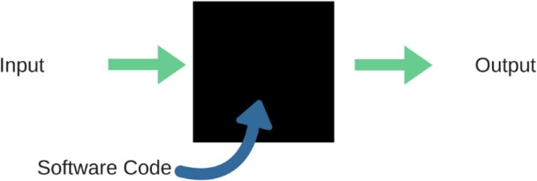

**Fig.:**Black Box Testing

When applied to AI models, discovery testing would mean testing AI models without realizing the inside subtleties, for example, highlights of the AI

model, the calculation used to make the model and so on. The test, in any case, is to check the test result against the normal qualities that are known in advance.

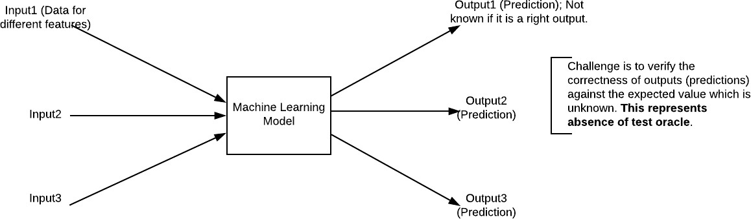

**Fig.:**Black Box Testing for Machine Learning algorithms

The above Fig.4.2 addresses the black box testing method for AI calculations.

|  |  |  |
| --- | --- | --- |
| **Input** | **Actual Output** | **Predicted Output** |
| [16,6,324,0,0,0,22,0,0,0,0,0,0] | 0 | 0 |
| [16,7,263,7,0,2,700,9,10,1153,832,9,2] | 1 | 1 |

## The model gives out the right result when various data sources are given which are referenced in Table 4.1. In this way the program is supposed to be executed true to form or address program

|  |  |  |
| --- | --- | --- |
| **Input** | **Actual Output** | **Predicted Output** |
| [16,6,324,0,0,0,22,0,0,0,0,0,0] | 0 | 0 |
| [16,7,263,7,0,2,700,9,10,1153,832,9,2] | 1 | 1 |

The model gives out the correct output when different inputs are given which are mentioned in Table 4.1. Therefore the program is said to be executed as expected or correct program

|  |  |  |  |  |  |  |  |
| --- | --- | --- | --- | --- | --- | --- | --- |
| Test | Test Case | Test Case | Test Steps | | | Test | Test |
| Cas | Name | Description | Step | Expected | Actual | Case | Priorit |
| e Id |  |  |  |  |  | Statu | Y |
|  |  |  |  |  |  | s |  |
| 01 | Start the | Host the | If it | We | The | High | High |
|  | Applicatio | application | doesn't | cannot | application |  |  |
|  | N | and test if it | Start | run the | hosts |  |  |
|  |  | starts |  | applicati | success. |  |  |
|  |  | making sure |  | on. |  |  |  |
|  |  | the required |  |  |  |  |  |
|  |  | software is |  |  |  |  |  |
|  |  | available |  |  |  |  |  |
| 02 | Home Page | Check the | If it | We | The | High | High |
|  |  | deployment | doesn’t | cannot | application |  |  |
|  |  | environmen | load. | access | is running |  |  |
|  |  | t for |  | the | successfully |  |  |
|  |  | properly |  | applicati | . |  |  |
|  |  | loading the |  | on. |  |  |  |
|  |  | application. |  |  |  |  |  |
| 03 | User | Verify the | If it | We | The | High | High |
|  | Mode | working of | doesn’t | cannot | application |  |  |
|  |  | the | Respond | use the | displays the |  |  |
|  |  | application |  | Freestyle | Freestyle |  |  |
|  |  | in freestyle |  | mode. | Page |  |  |
|  |  | mode |  |  |  |  |  |
| 04 | Data Input | Verify if the | If it fails | We | The | High | High |
|  |  | application | to take the | cannot | application |  |  |
|  |  | takes input | input or | proceed | updates the |  |  |
|  |  | and updates | store in | further | input to application |  |  |
|  |  |  | The |  |  |  |  |
|  |  |  | Database |  |  |  |  |

**CHAPTER-11**

**EXPERIMENTATION RESULTS**

**10.EXPERIMENTATION RESULTS**

In this undertaking we are utilizing different AI calculation to foresee or conjecture flood circumstance as this is a characteristic catastrophe which can cause immense loss of lives and monetary resources. Opportune and exact forecast of future floods can help in decrease such misfortune and to foresee flood precisely we have assessed execution different AI calculations like SVM, Strategic Relapse, MLP and KNN. In all calculations MLP is giving best execution and to carry out this task we have utilized beneath flood dataset from KAGGLE site.

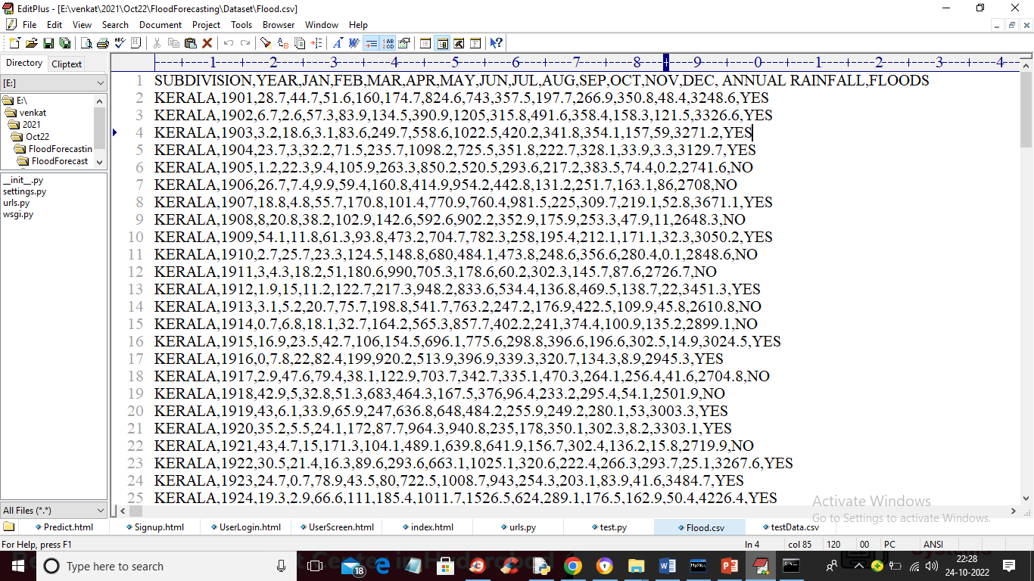

In above dataset first line contains dataset segment names and remaining columns contains dataset values. In each column we have month to month and yearly precipitation and in light of that we have class mark as YES (flood happen) and negative (no flood happen). So by utilizing above dataset we will prepare all calculations and assess their presentation with regards to exactness, accuracy, review, FSOCRE, awareness and particularity.

To foresee flood we are utilizing beneath test information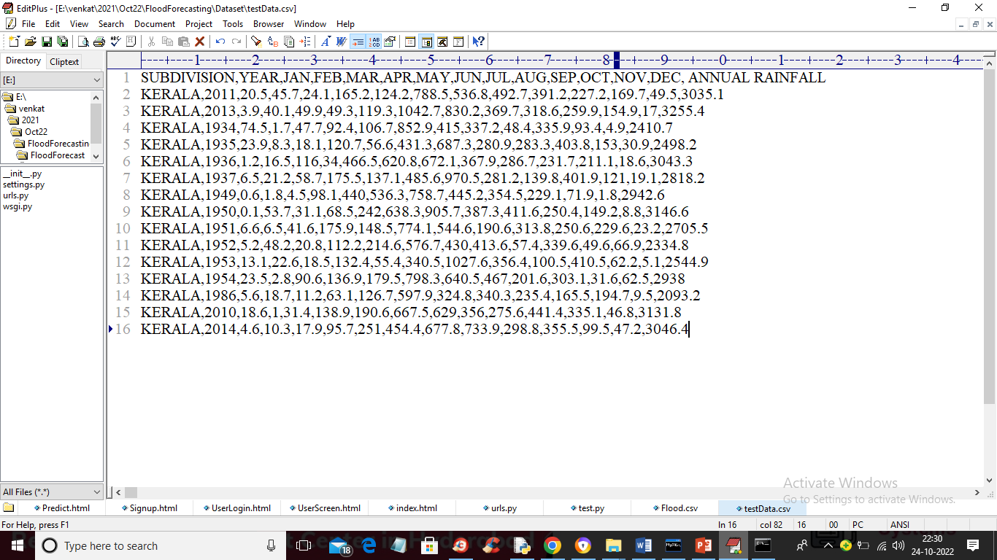

In above test information we have month to month and yearly precipitation without flood name and when we apply this dataset on MLP calculation then it will foresee flood will happen or not.

To execute this undertaking we have planned following modules

1) New Client Information exchange Here: utilizing this module we will permit client to information exchange with the application

2) User Login: utilizing this module we will permit client to login to application

3) Preprocess Dataset: utilizing this module we will peruse flood dataset and afterward eliminate missing qualities and afterward standardize dataset values and afterward split dataset into train and test where application utilize 80% dataset for preparing and 20% for testing

4) Run AI Calculations: utilizing this module we will prepare each of the 4 AI calculations like SVM, Strategic Relapse, KNN and MLP and compute forecast exactness on test information

5) Forecast Flood: utilizing this module we will transfer test information and afterward MLP will anticipate flood from that test information

To run project double tap on 'run.bat' document to begin python DJANGO web server and get underneath yield

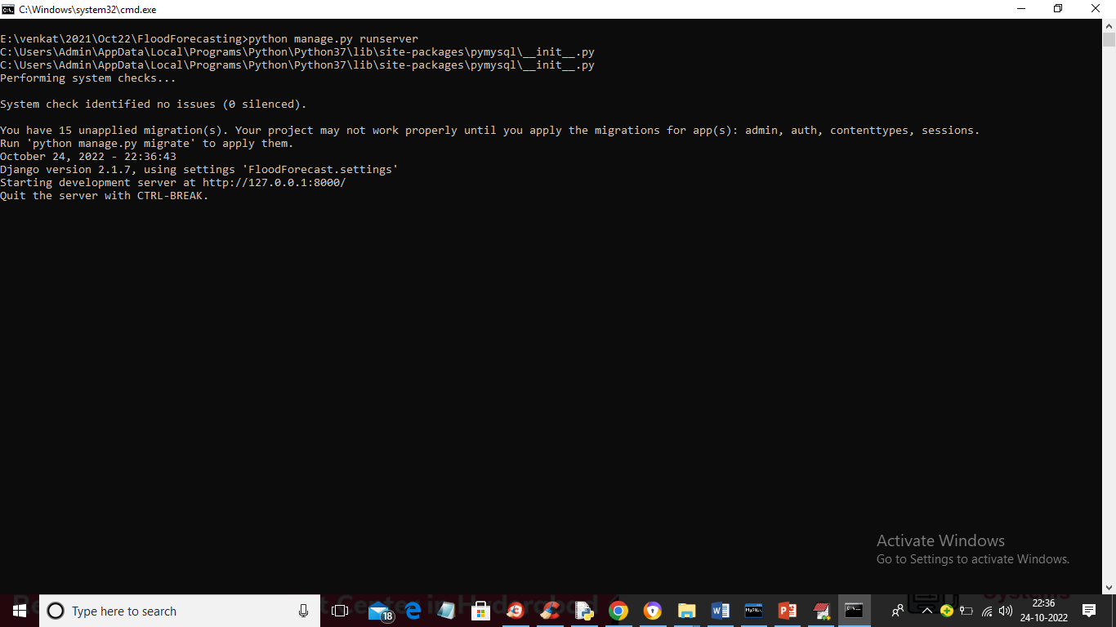

In above screen python DJANGO server began and presently open program and enter URL as http://127.0.0.1:8000/index.html and press enter key to get underneath page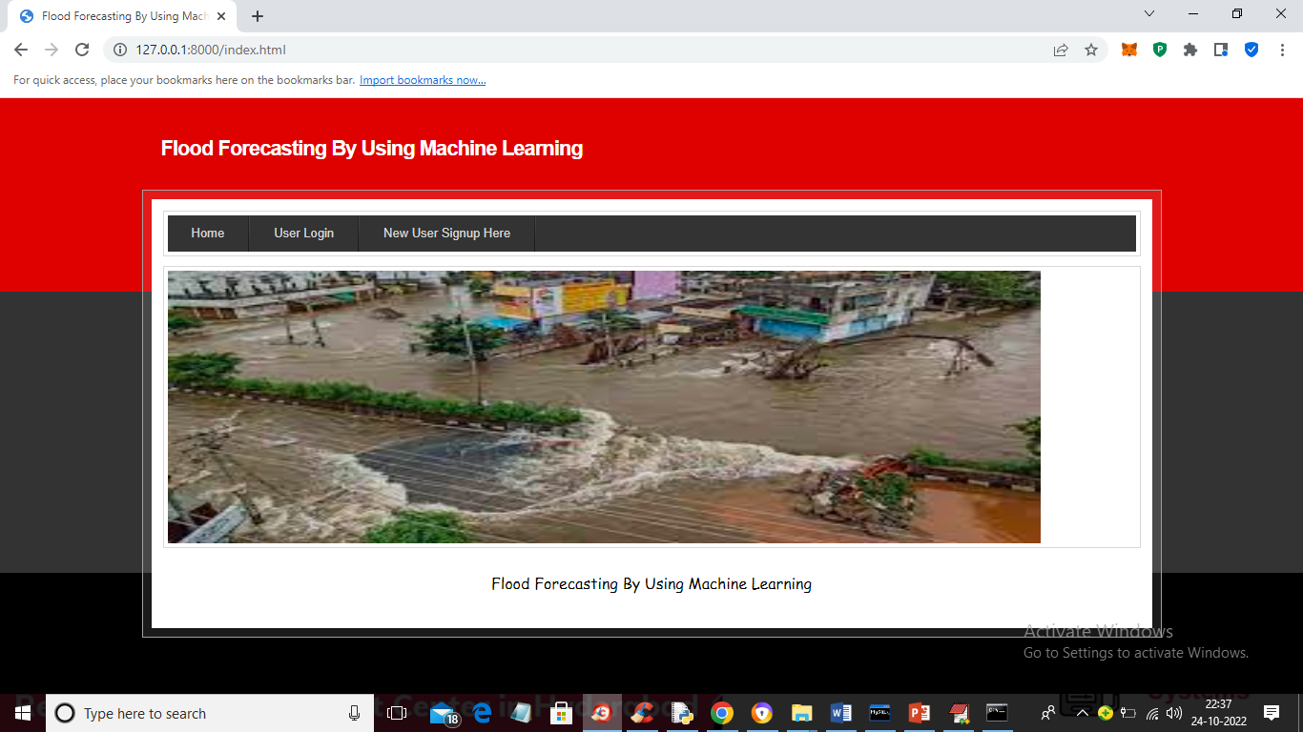

In above screen click on 'New Client Data trade Here' association with get under page

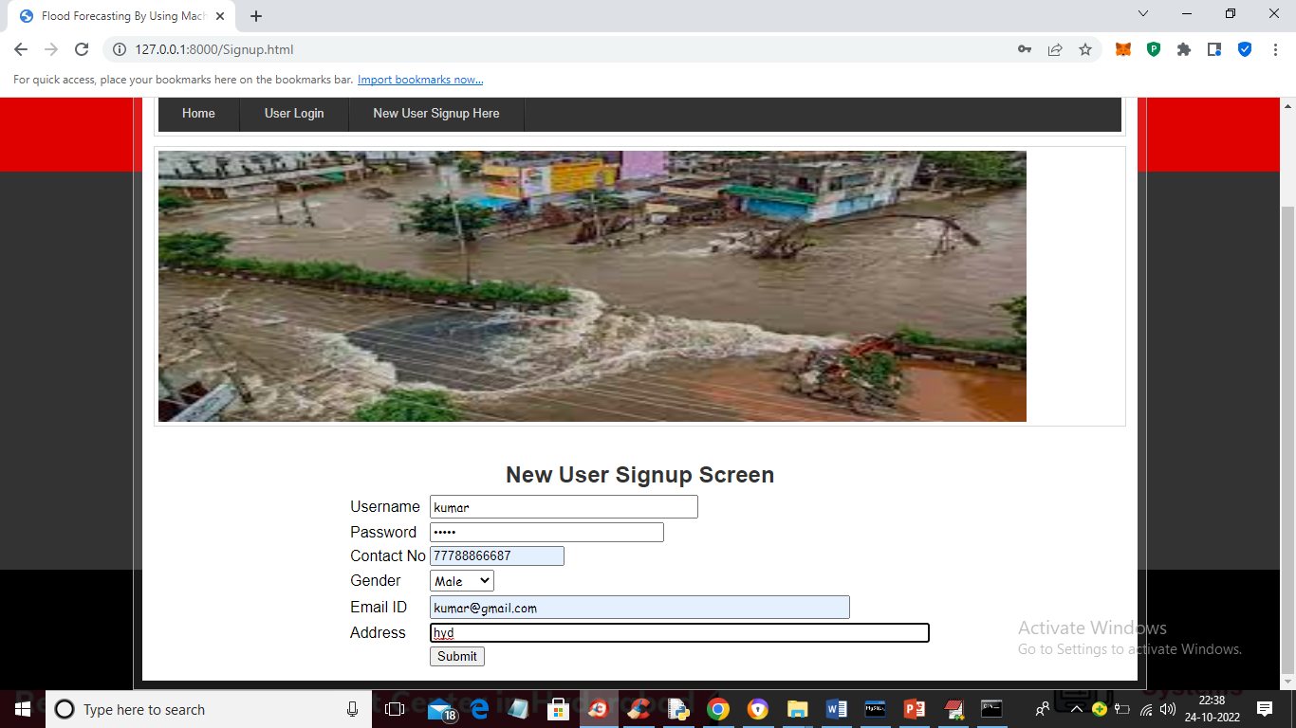

In above screen client is joining and afterward click on 'Submit' button to finish information exchange and get beneath yield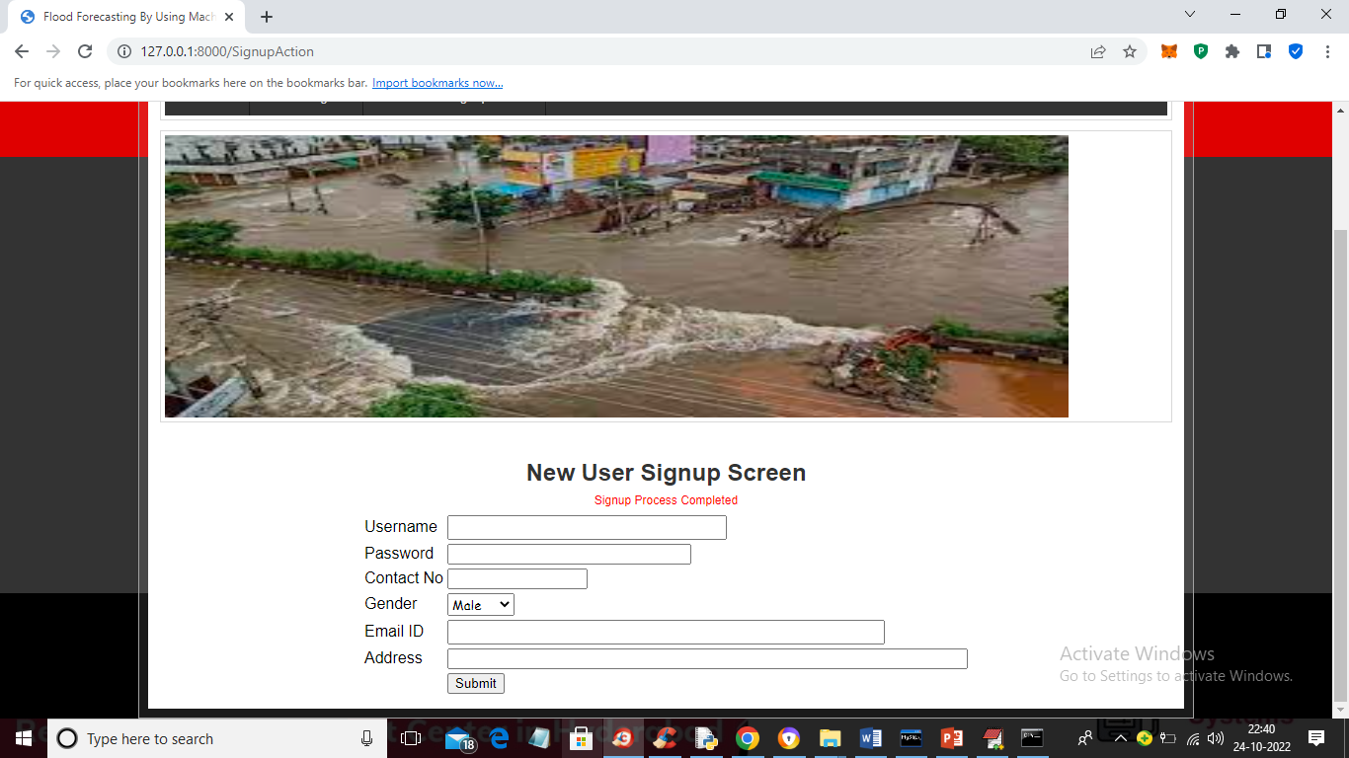

In above screen information exchange process finished and presently click on 'Client Login' connection to get beneath login screen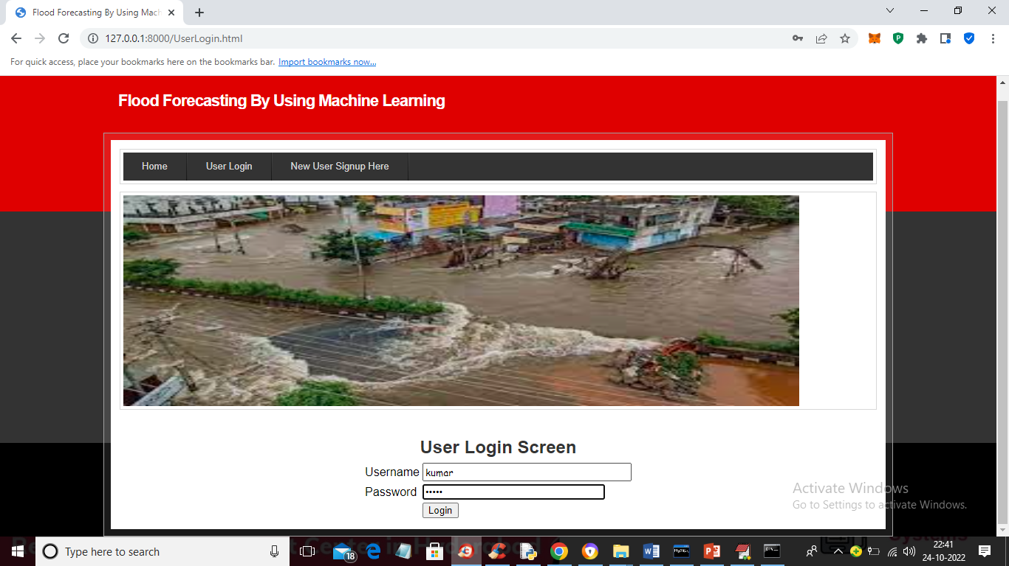

In above screen client is login and after login will get underneath yield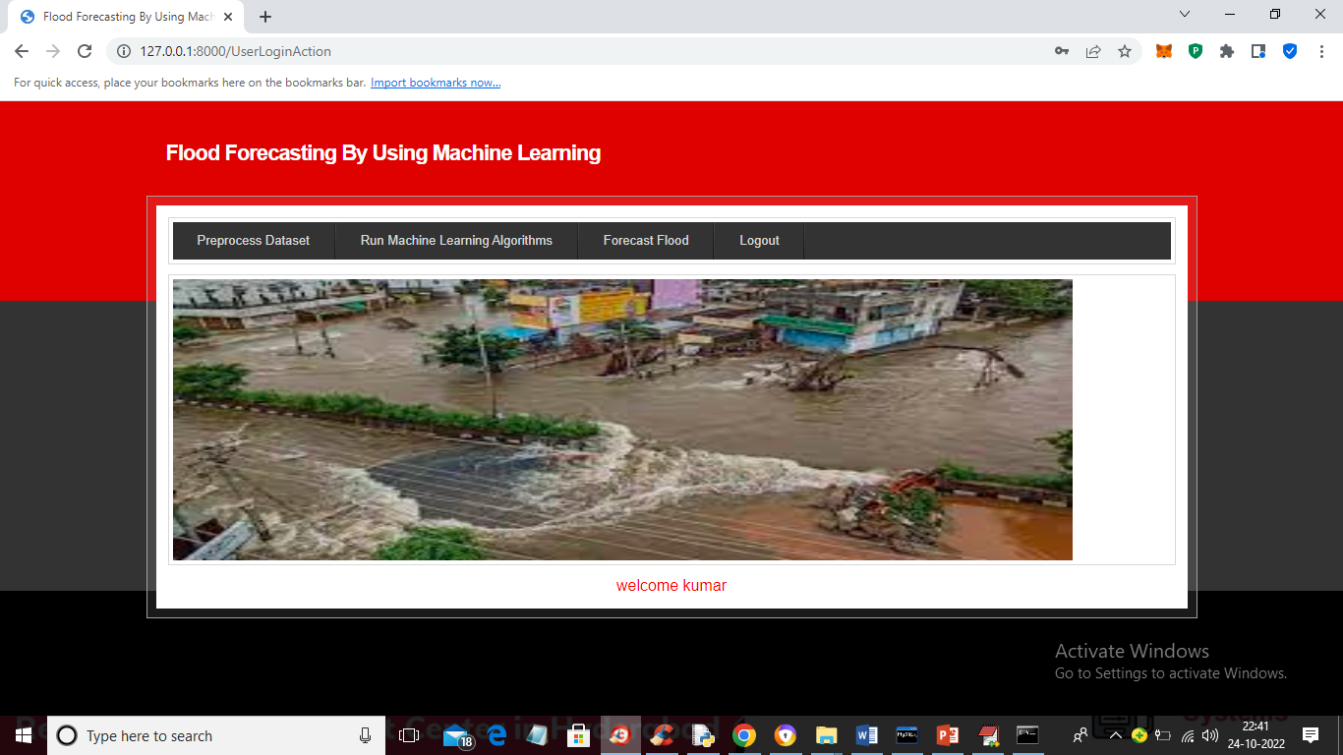

In above screen click on 'Preprocess Dataset' connection to load and process dataset and get beneath yield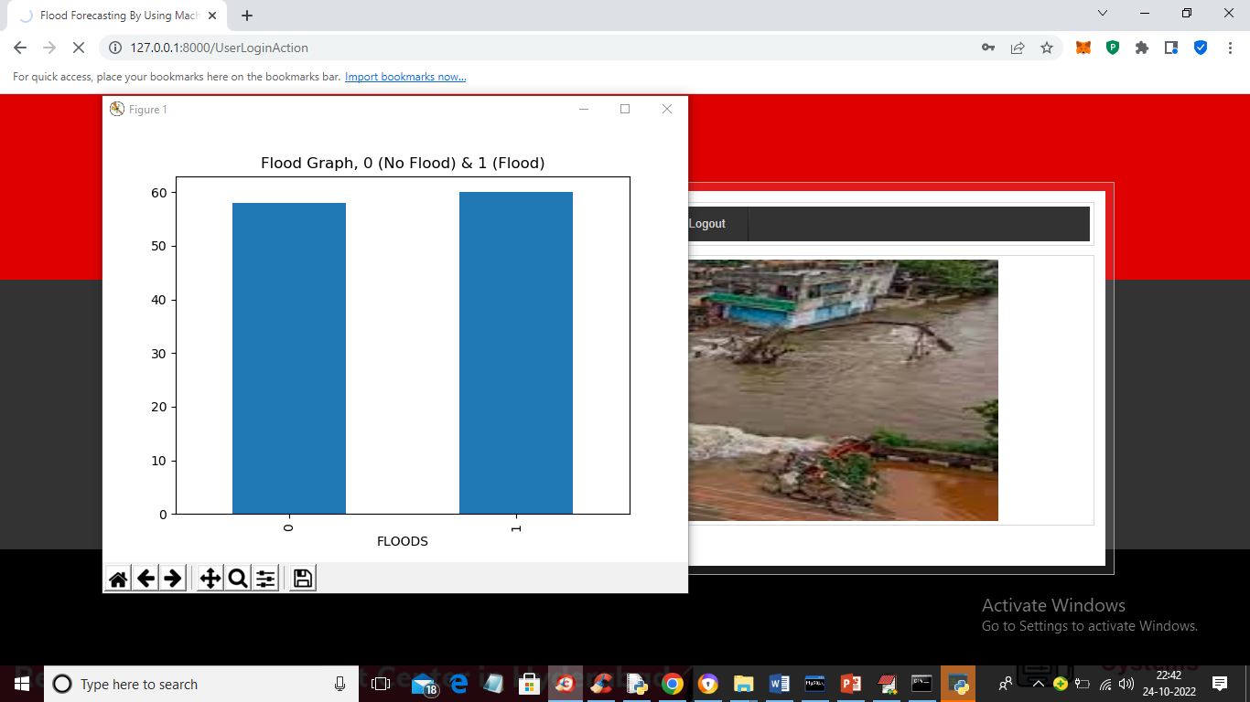

In above screen dataset handling finished and in chart x-hub addresses names as 0 (no flood) and 1 (flood) and y-pivot addresses number of records in that mark and presently close above diagram to get beneath yield. By utilizing mark encoding handling method we have changed over YES and NO to 0 and 1 as AI calculations acknowledge just numeric information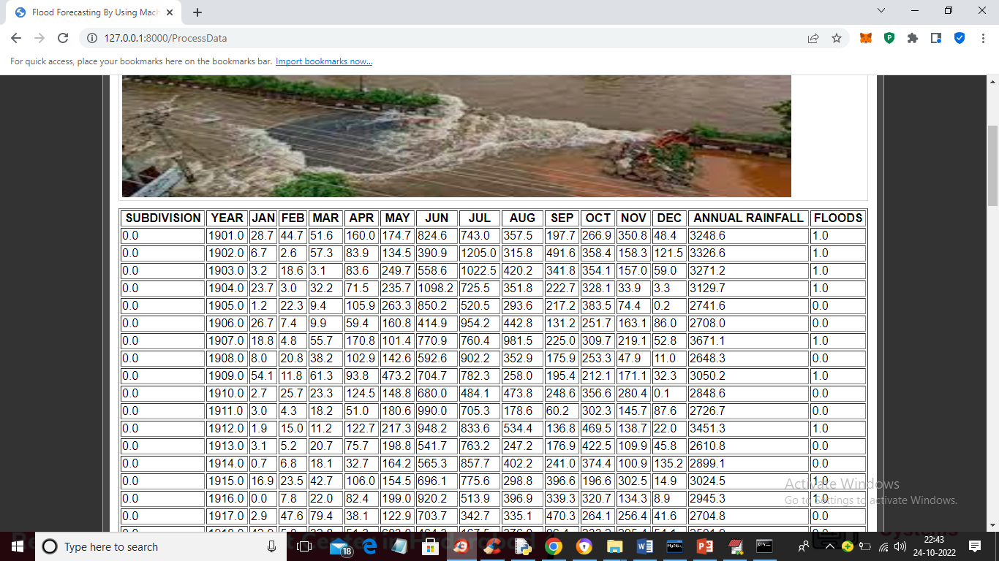

In above screen whole dataset process and stacked and presently click on 'Run AI Calculations' connect to prepare all calculations and get underneath yield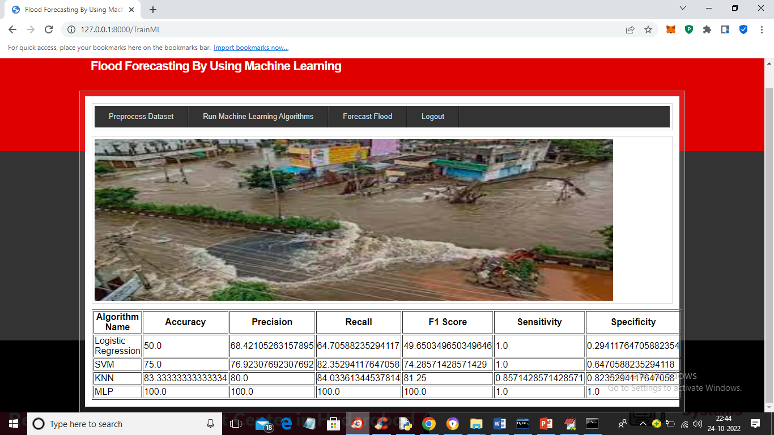

In above screen in even arrangement we can find in all calculations MLP got most elevated exactness as 100 percent and for each run this precision might differ from 95 to 100 percent. Presently calculations are prepared and presently click on 'Timberland Flood' connection to get beneath screen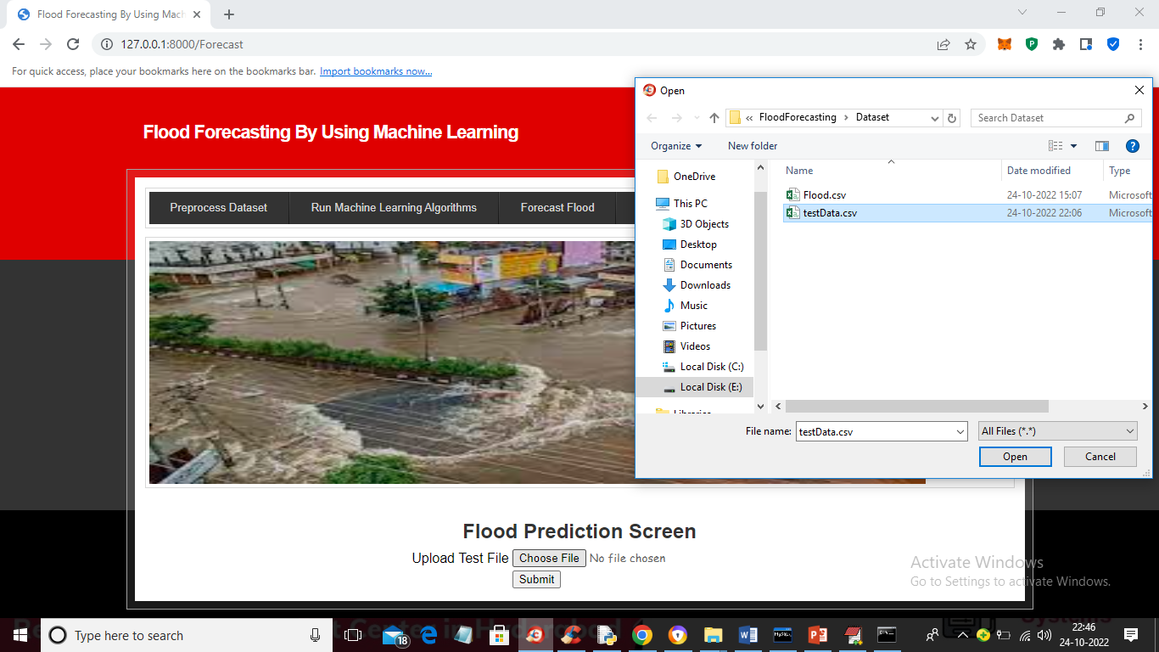

In above screen select and upload ‘testData.csv’ file and then click on ‘Open’ and ‘Submit’ button to load test data and get prediction output like below screen. This testData.csv is available inside ‘Dataset’ folder

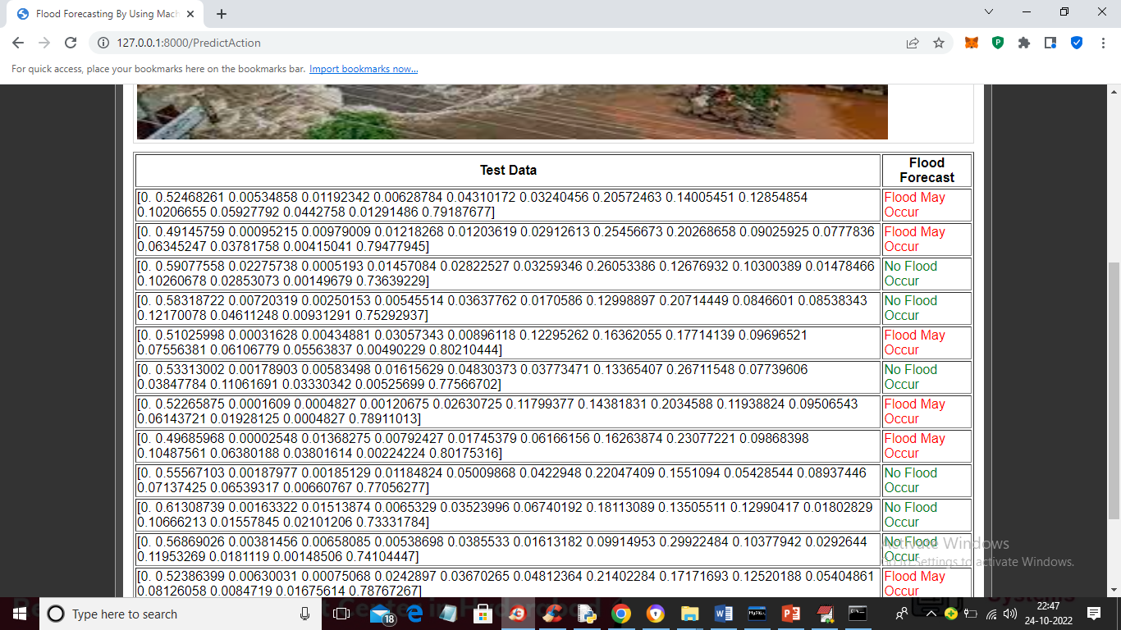

In above screen in first section we can see the Precipitation month to month and yearly test information and in last segment we can see expectation yield as 'Flood Might Happen' in red tone and 'No Flood Happen' in green tone.

#### URL listing

|  |  |
| --- | --- |
| Websites | Data collected |
| <https://wikipedia.org> | Searching of any information that will be used in documentation. |
| <https://dev.sqlserver.com/doc> | SQL server it performing in mainly depending on the one of the database using. |
| <https://www.answers.com> | Answers.com, online dictionary, encyclopedia and much more. |
| <https://google.co.in> | Any information searching and downloading. |
| <https://training-classes.com> | Designing part information as gathered |

**CHAPTER-11**

**CONCLUSION**

**11.CONCLUSION**

**CONCLUSION:**

The most common way of streaming in values at the beginning time and end of the jth time span are Ij and Ij+1 separately and comparing the worth of surge are Qj and Qj+1. AI ready to learn and further develop framework in an unequivocal way. AI gives PC programs that can approach or get or recover access information with learning it. AI capable with to compute enormous informational index. Counterfeit Smart framework (AIS) used to prepare information in such method for further developing flood guaging framework with happening at a beginning phase improvement cautioning framework

**SCOPE :**

the speculation capacity of the models and diminished the vulnerability of expectation. The fourth was the utilization of extra enhancer calculations to work on the nature of AI calculations, e.g., for better tuning the ANNs to arrive at ideal neuronal models. It is normal that, through these four key advancements, flood expectation will observer critical upgrades for both present moment and long haul forecasts. Most likely, the headway of these clever ML strategies relies exceptionally upon the appropriate utilization of delicate processing procedures in planning novel learning calculations. This reality was talked about in the paper, and the delicate figuring strategies were presented as the principal givers in creating cross breed ML techniques for what's to come

**CHAPTER-12**

**REFERENCE**

[1] Pappenberger, F.; Cloke, H.L.; Parker, D.J.; Wetterhall, F.; Richardson, D.S.; Thielen, J. The money related advantage of early flood alerts in Europe. Environ. Sci. Strategy 2015, 51, 278-291.

[2] Krzysztofowicz, R. Bayesian framework for probabilistic waterway stage anticipating. J. Hydrol. 2002, 268, 16-40.

[3] Todini, E. Job and treatment of vulnerability progressively flood guaging. Hydrol. Process. 2004, 18, 2743-2746.

[4] Clark, M.P.; Slater, A.G. Probabilistic quantitative precipitation assessment in complex territory. J. Hydrometeorol. 2006, 7, 3-22.

[5] Vrugt, J.A.; Robinson, B.A. Treatment of vulnerability utilizing outfit techniques: Correlation of successive information absorption and Bayesian model averaging. Water Assets. 2007, 43.

[6] Ebtehaj, M.; Moradkhani, H.; Gupta, H.V. Further developing power of hydrologic boundary assessment by the utilization of moving block bootstrap re-examining. Water Resour. Res. 2010, 46.

[7] He, X.; Refsgaard, J.C.; Sonnenborg, T.O.; Vejen, F.; Jensen, K.H. Factual examination of the effect of radar precipitation vulnerabilities on water assets demonstrating. Water Assets. 2011, 47.

[8] Legleiter, C.J.; Kyriakidis, P.C.; McDonald, R.R.; Nelson, J.M. Impacts of dubious geological information on two layered stream demonstrating in a rock bed waterway. Water Resour. Res. 2011, 47.

[9] Sikorska, A.E.; Scheidegger, A.; Banasik, K.; Rieckermann, J. Bayesian vulnerability evaluation of flood expectations in ungauged metropolitan bowls for theoretical precipitation spillover models. Hydrol. Earth Syst. Sci. 2012, 16, 1221-1236.

[10] Montanari, A.; Koutsoyiannis, D. An outline for process-based displaying of questionable hydrological frameworks. Water Resour. Res. 2012, 48.

[11] Prof.ParthasarathiChoudhary and A. Sankarasubramanian(2009), "Waterway Flood Anticipating Utilizing Corresponding Muskingumrating Equations",Journal of Hydrologic Designing, Vol. 14, No. 7, July 1, 2009.

[12] KoradaHariVenkataDurga Rao, ValaVenkateshwar Rao, Vinay Kumar Dadhwal, GandarbhaBehera, and Jaswant Raj Sharma, "A Disseminated Model for Ongoing Flood Determining In The Godavari Bowl Utilizing Space Data sources", Worldwide Diary Debacle Hazard Sci. 2011, 2 (3): 31-40.

[13] Sulafa Witch Elsafi(2014) "Fake Brain Organizations (Anns) For Flood Determining At Dongola Station In The Waterway Nile, Sudan", Alexandria Designing Diary (2014) 53, 655-662.